Power Shell 101
Module 1A – Visual Studio Code (VSCode)
3/2/2019 Developed by Sam Chung
10/3/2020 Reviewed by Kim Nguyen

Center for Information Assurance (CIAE) @City University of Seattle (CityU)

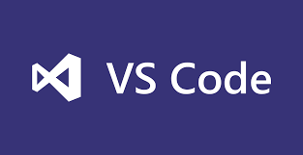
Learning Outcomes
- Learn how to install Microsoft “Visual Studio Code (VSCode)

Resources
- Visual Studio Code, https://code.visualstudio.com/
- Cmd commands under Windows, https://www.thomas-krenn.com/en/wiki/Cmd_commands_under_Windows

Activities
- Downloading
- Installing
- Testing
- Q&A

Downloading
- Visit https://code.visualstudio.com/
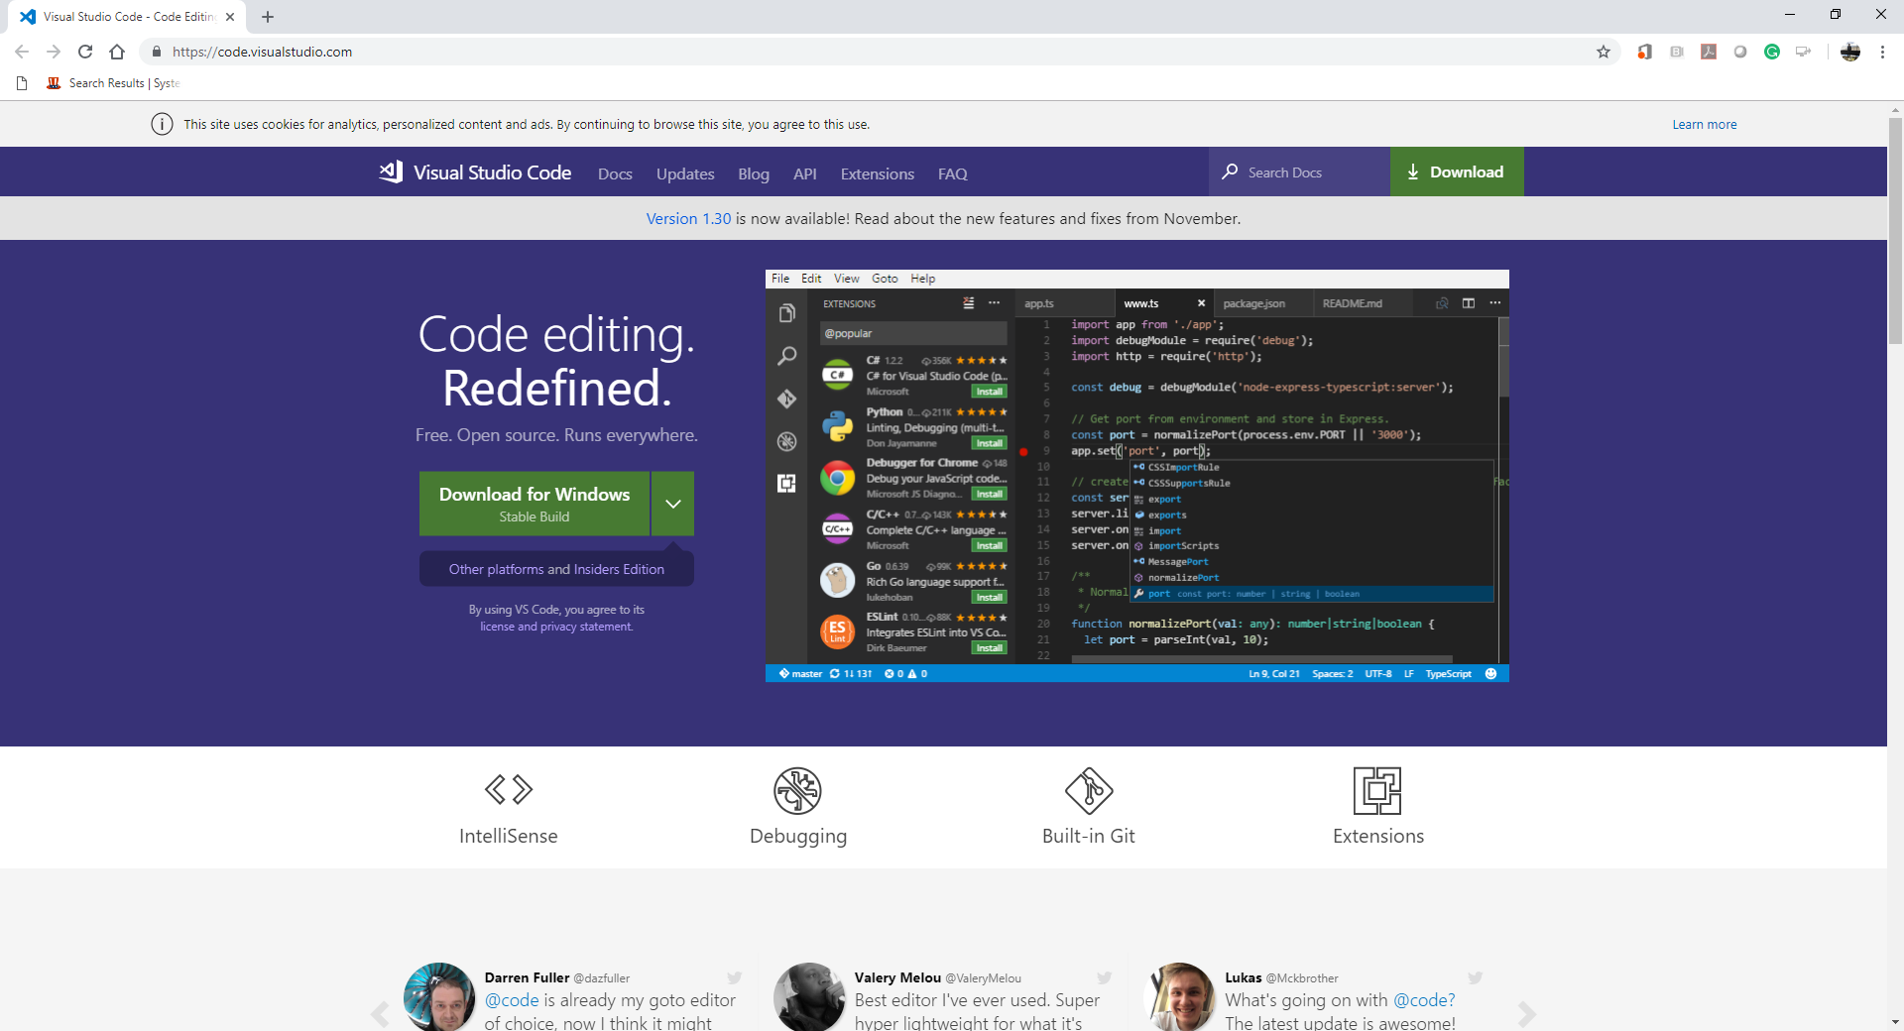

- Select a correct version for your operating system.
For example, you can select “Windows x64” for your Windows 10.
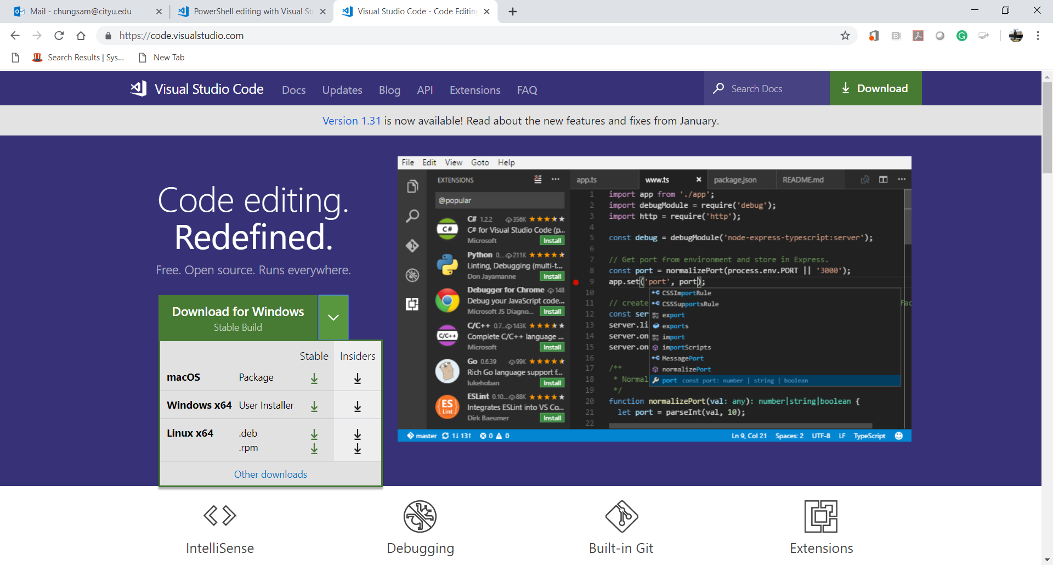

- Then, you can download “VSCodeUserSetup-x64-1.30.2” for your Windows 10.
- The “Getting Started” webpage will be displayed.
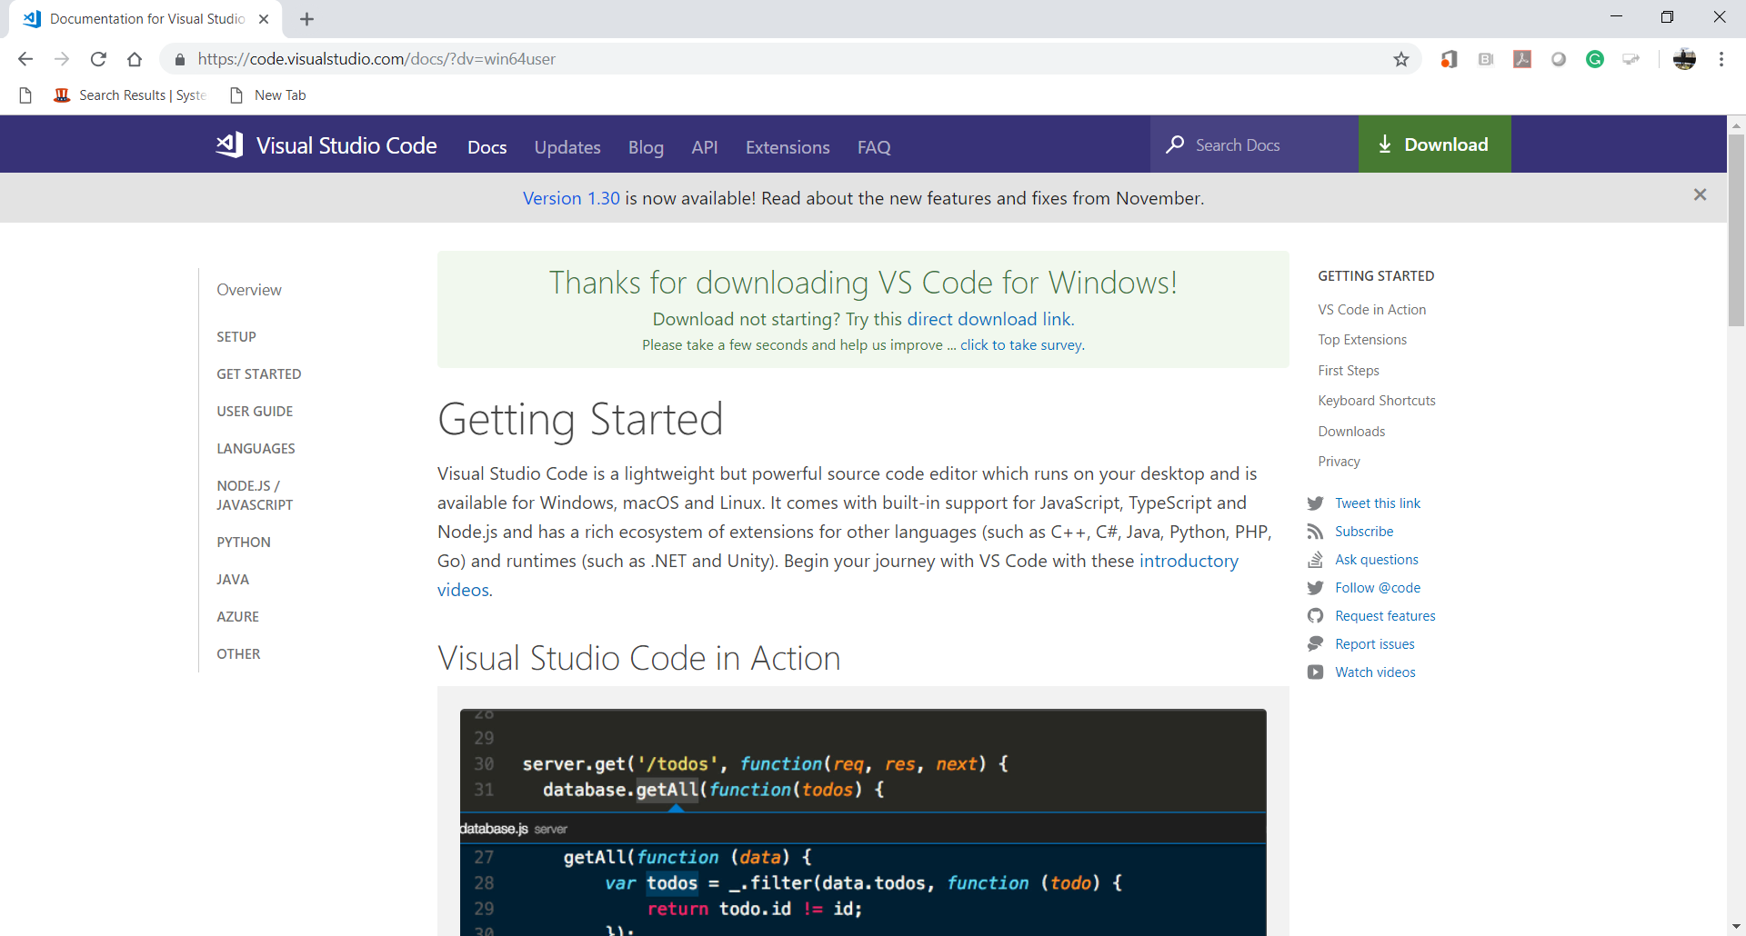

Installing
- Install VSCode.
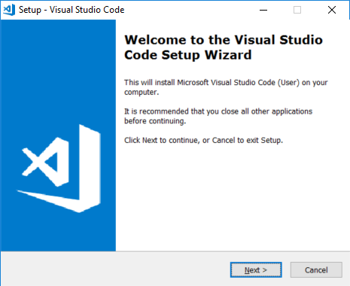
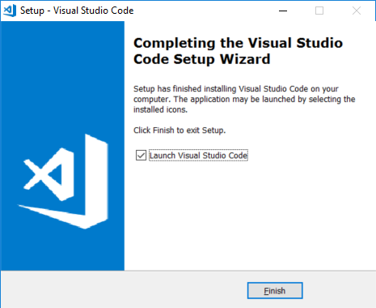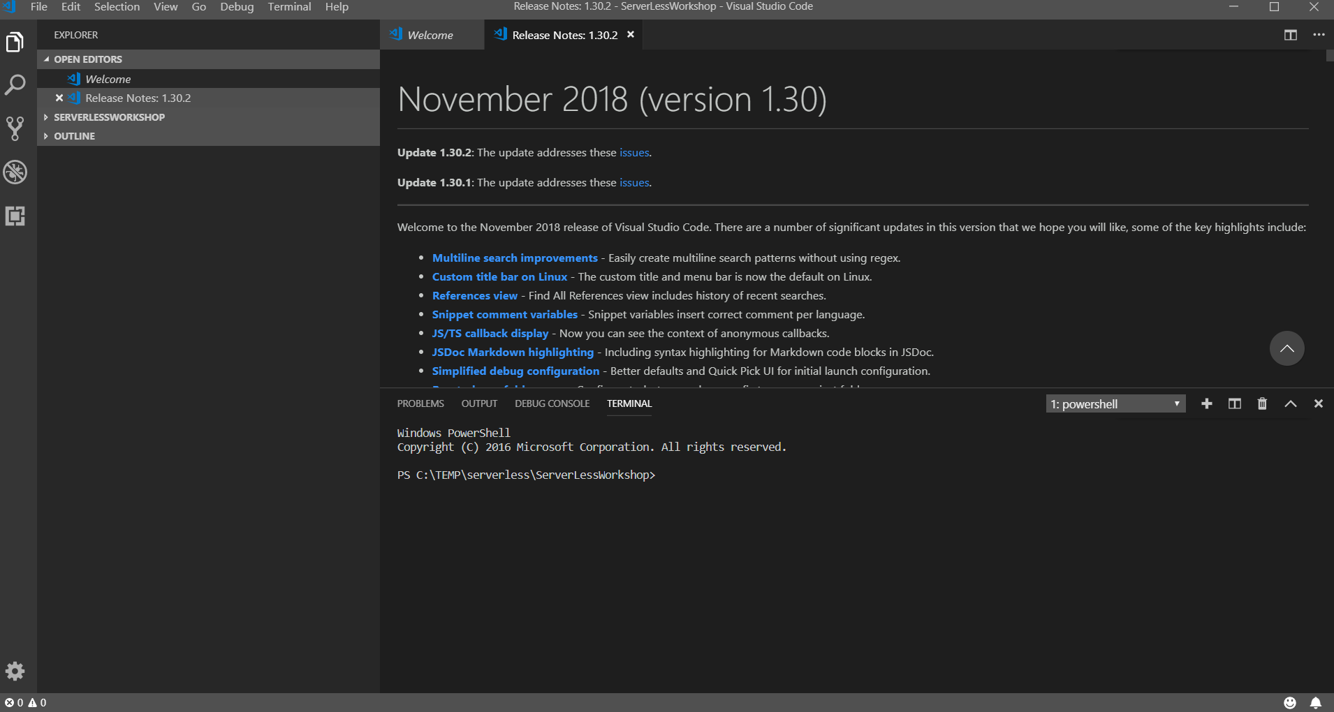

- After installing the VSCode, close the VSCode.
Go to “File” menu end select ‘Exit” menu item.

Testing
- Open the VSCode.
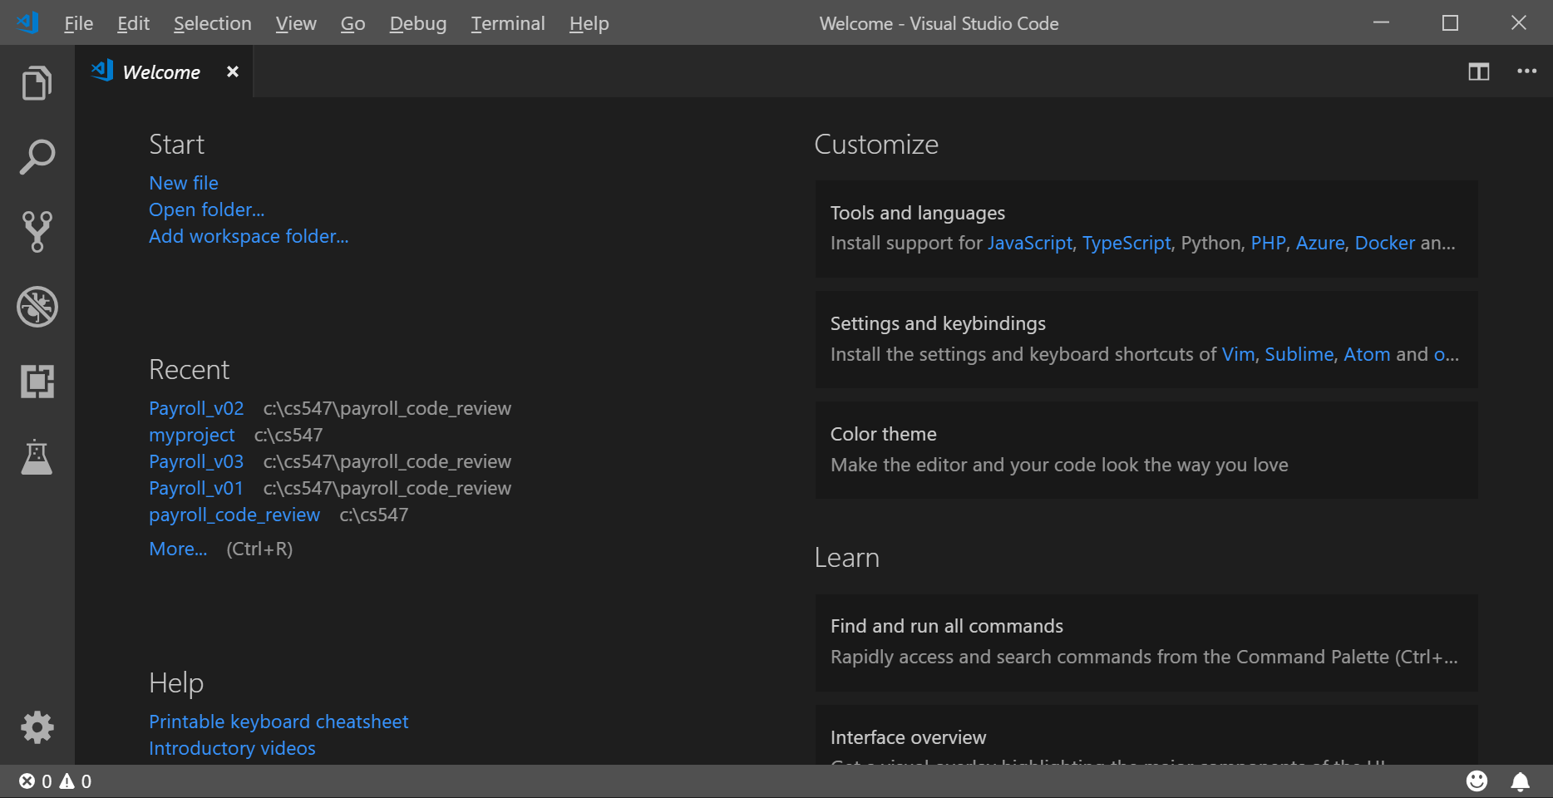

- Go to “View” menu and select “Terminal” menu item for your Command Line Interface (CLI).
Or you can type “Ctrl+~”
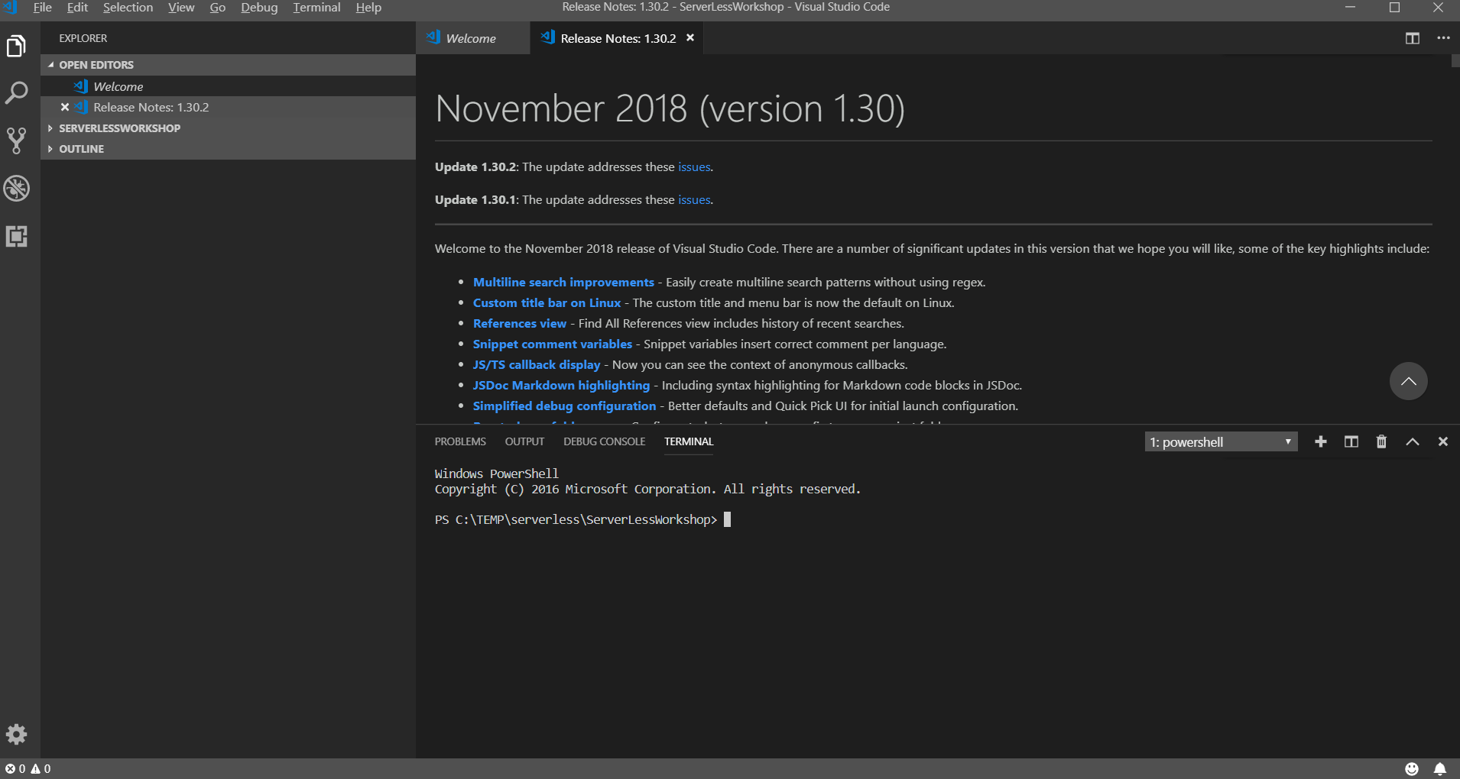

- Go to the root directory of your disk drive.
Create a working directory called “isec505” for your course and move to the directory.
The following commands under Windows will be used.
>> cd /
>> mkdir isec505
>> cd isec505
>> dir
For more information about Windows commands, please visit https://www.thomas-krenn.com/en/wiki/Cmd_commands_under_Windows
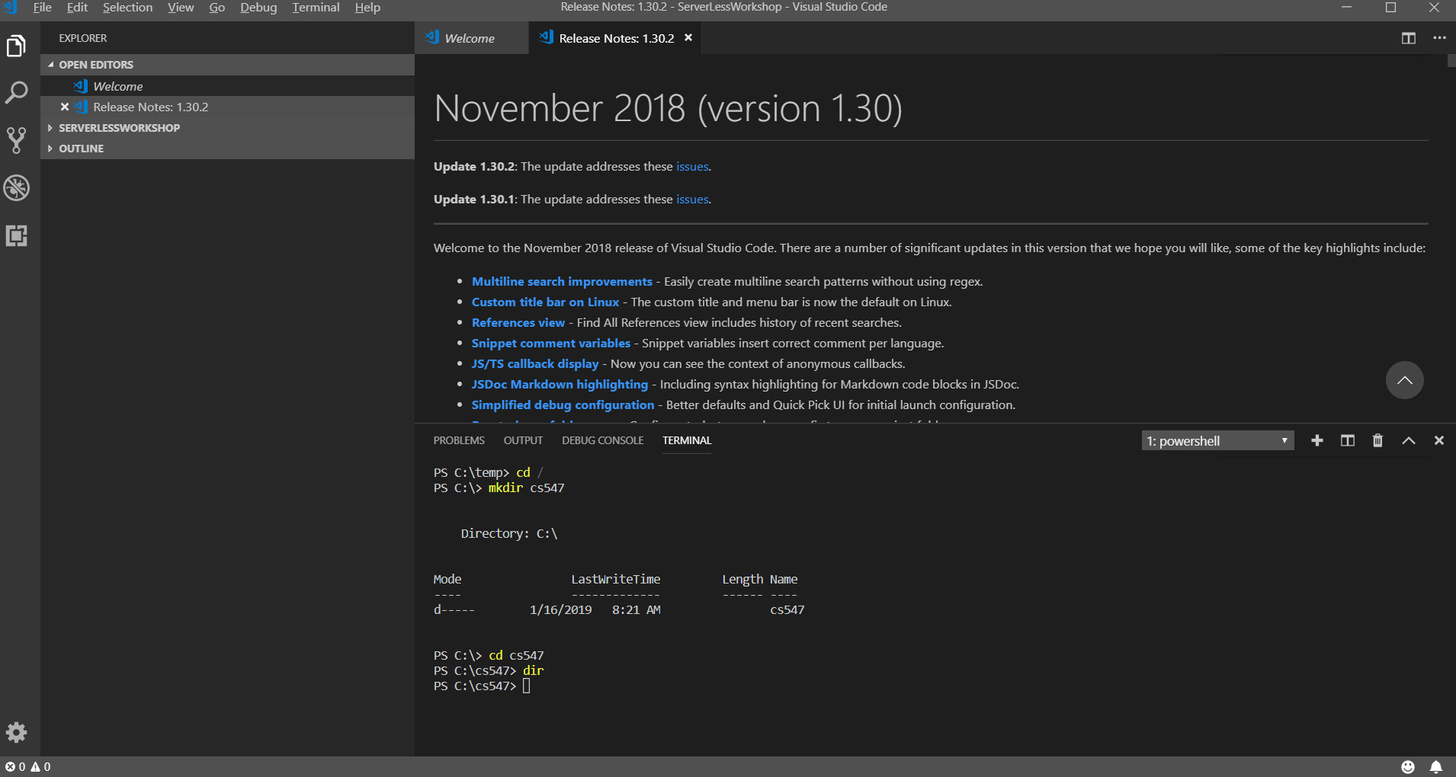

- Clear your CLI.
>> cls

- Close the VSCode.
Q&A
Justify your answers with at least one reference.
- What is Visual Studio Code?
Visual Studio Code is a lightweight version of Visual Studio, that is available on Windows, Mac, and Linux operating systems. The reason Visual Studio Code is lightweight is because it is actually just a customizable text editor, as compared to Visual Studio, which is an IDE. Although Visual Studio Code is just a text editor, with the available extensions it’s possible to make VS Code function very similar to a full fledged IDE.

- Why do you use the Visual Studio Code instead of Visual Studio (Community edition)?

I use Visual Studio Code instead of Visual Studio because I prefer the small size and performance of VS Code, as compared to VS. I have found that I can find extensions within VS Code to meet all of my needs for classes at City U, although I prefer a different editor for personal work/projects.

Reference:
Heller, M. (2019, September 09). Visual Studio Code vs. Visual Studio: How to choose. Retrieved October 10, 2020, from https://www.infoworld.com/article/3436860/visual-studio-code-vs-visual-studio-how-to-choose.html

